18.37:

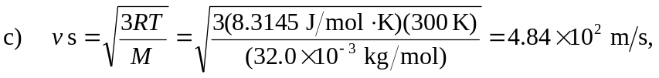

which is of course the square root of the result of part (b).

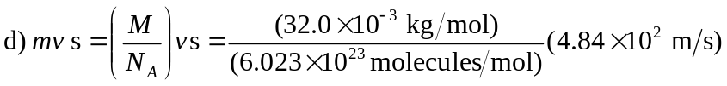
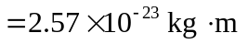

This may also be obtained from

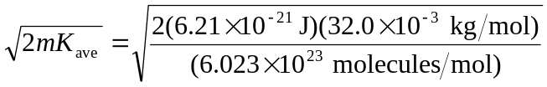

e) The average force is the change in momentum of the atom, divided by the time between collisions. The magnitude of the momentum change is twice the result of part (d) (assuming an elastic collision), and the time between collisions is twice the length of a side of the cube, divided by the speed. Numerically,

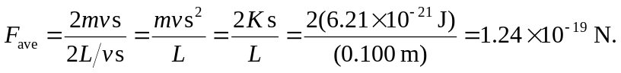

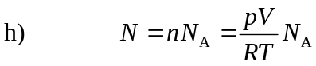
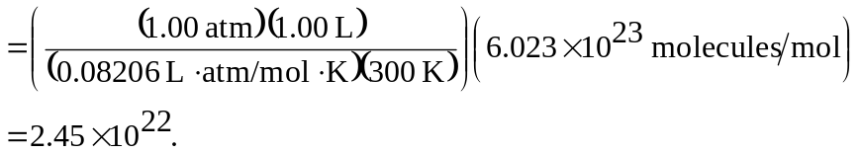

i) The result of part (g) was obtained by assuming that all of the molecules move in the same direction, and that there was a force on only two of the sides of the cube.

